Graph Ilustrating relation between Total Ratings and Rating Score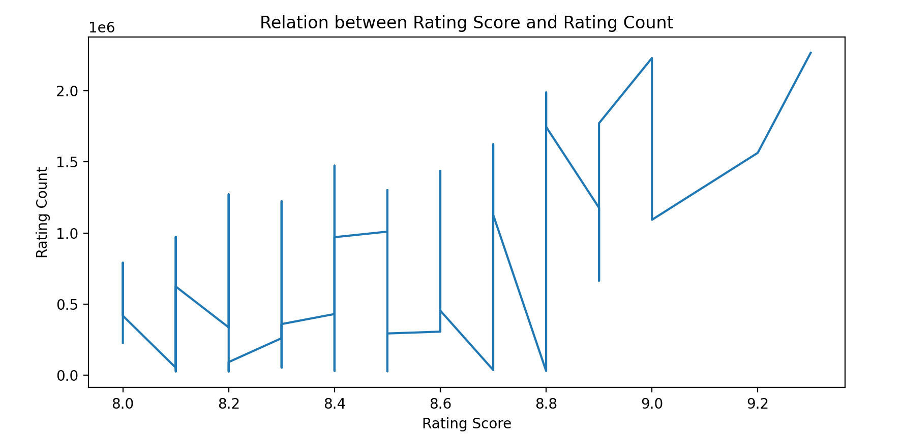
Graph Ilustrating relation between Budget and Rating:
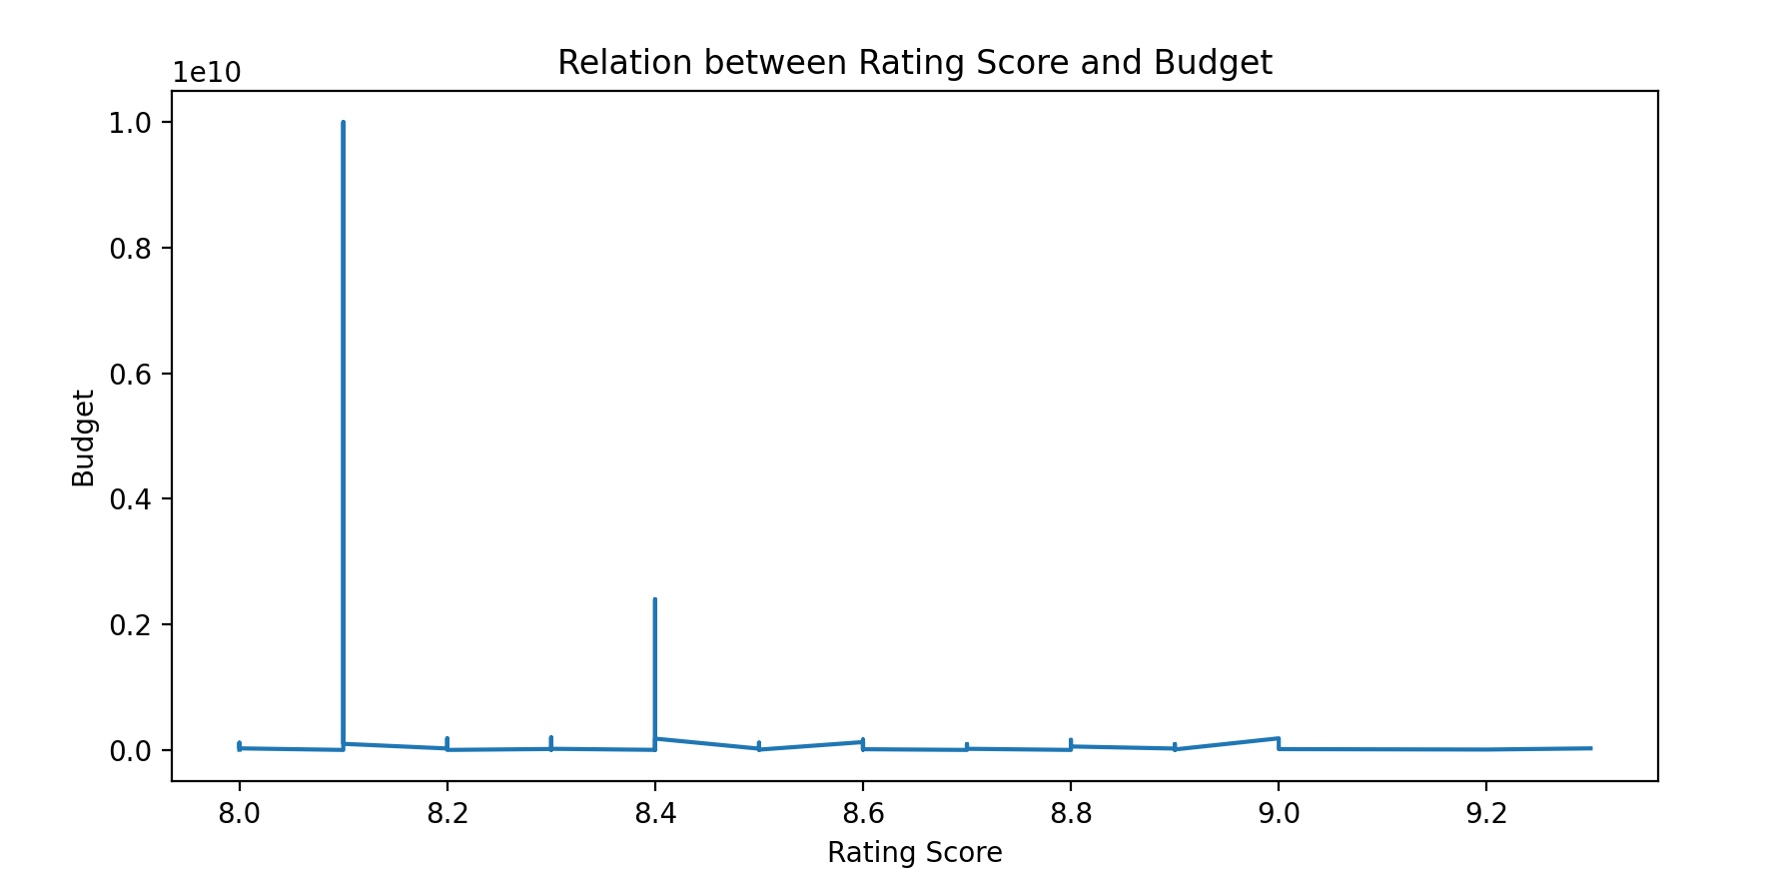

Average Earnings for each gener:

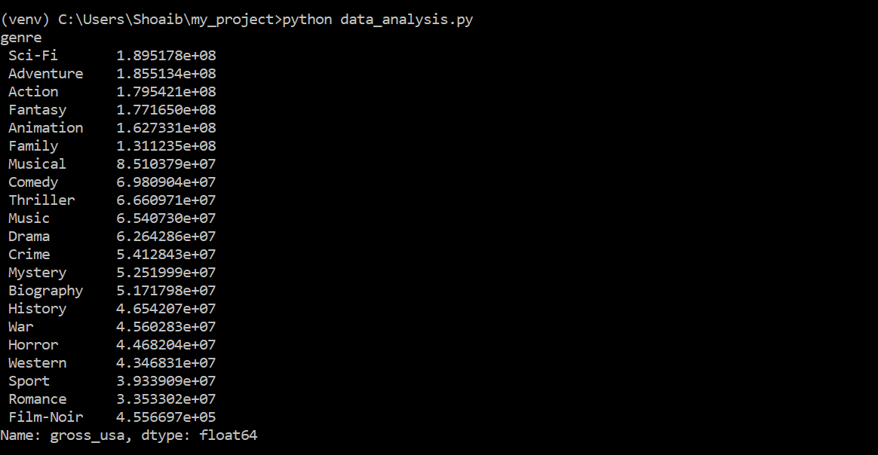

Technology Stack:
Scrapy:
Scrapy is a python framework designed for web scraping. I have chosen scrapy because it is latest and one of the fastest tool to scrape data and it provides a lot of features to handle extensible things in a simple way.
Pandas:
A python library for data manipulation. As it offers numerous data structures and operation for manipulating data that’s why I found it best according to the task requirement.
Matplotlib:
Python library for plotting graphs. After sorting out your data using pandas, matplotlib provides a simple way to plot graph from data and labeling it according to your requirements.

Time To Complete the task:
It took me 3 days working 5 hours each day to complete the task including system setup and learning time.

